BlueSnap Integration Guide

(JS Controllers version)

v 21.1.0



**Table of Contents**

**Summary** **3**

**Component Overview** **4**

Functional Overview 4

Limitations, Constraints 4

Compatibility 4

Privacy, Payment 4

**Implementation Guide** **5**

General Implementation 5

Installing the Cartridge on the sandbox 5

3.2 Set Up Business Manager 7

3.3 Configuring preferences: 14

3.3.1 Example of configuring the cartridge via BM extension: 14

3.3.2 How to modify payment method name 17

3.3.3 How to set SoftDescriptor for customer 17

3.3.4 How to use Bluesnap Reports 19

3.4 Integrating BlueSnap into your SiteGenesis storefront 20

3.4.1 Perform changes in templates 20

**Operations, Maintenance** **24**

Data Storage 24

Availability 24

Support 24

**User Guide** **24**

Roles, Responsibilities 24

Business Manager 24

Storefront Functionality 24

**Known Issues** **24**

**Release History** **24**

# **Summary**

This document provides technical instructions for using the BlueSnap SFCC Cartridge to integrate the BlueSnap payment methods into a SFCC storefront.

**Glossary**

|  |  |
| --- | --- |
| **Term** | **Description** |
| SFCC | SalesForce Commerce Cloud |
| Business Manager (BM) | The primary tool used to configure the SFCC platform and customer storefront |
| SiteGenesis 2.0 (SG2) | The SFCC default ecommerce storefront |

# **Component Overview**

## **Functional Overview**

The BlueSnap cartridge enables customers to select the BlueSnap payment methods on checkout and pay for order with the BlueSnap all-in-One Payment Platform. Service supports the following payment methods:

* Credit/Debit Cards payment processing.
* LATAM payments processing for local credit cards in Latin America. Supports the following countries with the specified cards:
  + Argentina — Amex, Argencard, Cabal, Cencosud, Diners, MasterCard, Nativa, Tarjeta Naranja, Tarjeta Shopping, Visa.
  + Brazil — Amex, Cartão MercadoLivr, Diners, Discover, ELO, Hipercard, JCB, MasterCard, Visa.
  + Chile — Amex, Diners, MasterCard, Visa.
  + Mexico — Amex, MasterCard, Visa.
* ACH (Automated Clearing House)/ECP payment.
* SEPA (Single Euro Payments Area) Direct Debit payment (only for Euro currency).
* Apple Pay payment processing. Apple Pay is accessible from newer versions of Safari and iOS.
* Google Pay payment processing.
* Visa Checkout digital wallet payment processing. It supports all major credit and debit card types, including Visa, MasterCard, American Express, and Discover Enable 3D Secure Payments.

In case the service is down, the storefront continues to work without the service. All errors work of the service are saved in the log file.

## **Limitations, Constraints**

Use of the BlueSnap cartridge requires credentials and keys from the BlueSnap. Please register on bluesnap.com and contact BlueSnap customer service.

The cartridge is designed for the US locale, but can work with other locales. Please note that some payment methods will work only with certain locales. For example, LATAM payment only works with Argentina, Brazil, Chile, Mexico locales. SEPA payment will only work with locales that use Euro currency. For more details, please contact BlueSnap customer service.

## **Compatibility**

The cartridge is designed for Salesforce Commerce Cloud API version 21.10 *with JS Controllers.* Compatibility Mode: 21.7. It is expected to be backward compatible with older versions of SFCC.

## **Privacy, Payment**

The BlueSnap cartridge can collect and process user profile information or billing information. For additional privacy information, please contact your BlueSnap Manager.

# **Implementation Guide**

## **General Implementation**

### **Installing the Cartridge on the sandbox**

1.  Open UX Studio.  
2.  Import downloaded cartridge. Select on the Import screen:

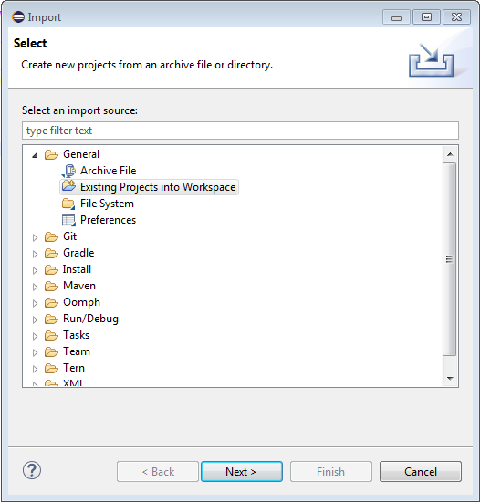m

3. Link the cartridge to the sandbox.

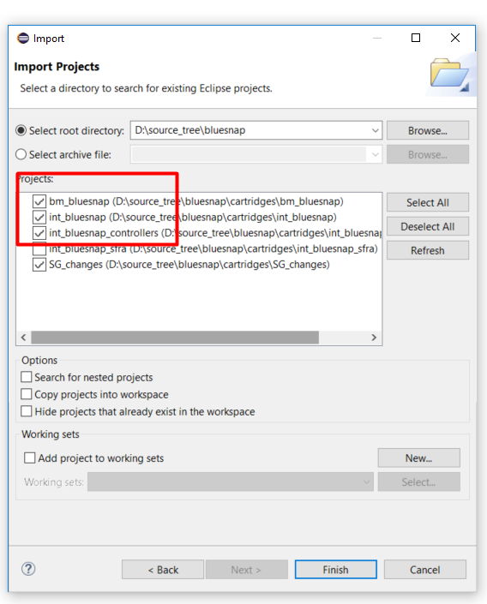

4. Select sandbox connection then Properties. Select Project Reference and check in. 

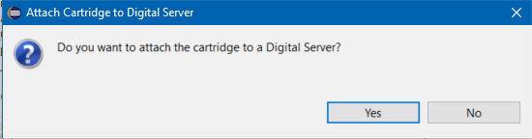

## 

## 

## 

## **3.2 Set Up Business Manager**

1.  Go to **Business Manager -> Site -> Manage Sites**. Select the correct site then select **Settings** tab. In the cartridge path add “int_bluesnap” and “int_bluesnap_controllers” cartridges:

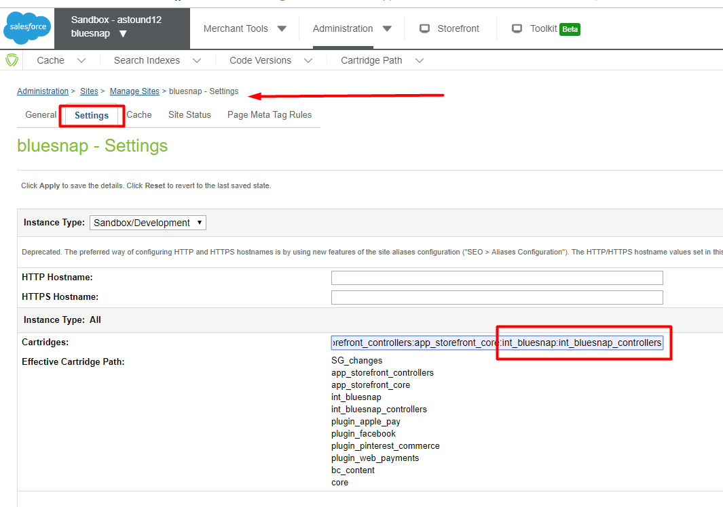

2.  Go to **Administration -> Site Development ->Site Import & Export** and upload bluesnap.zip from meta folder

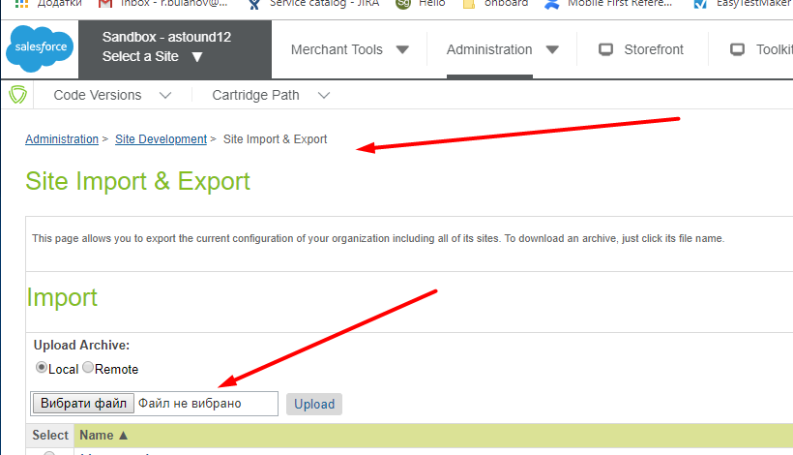

3. Import bluesnap.zip:

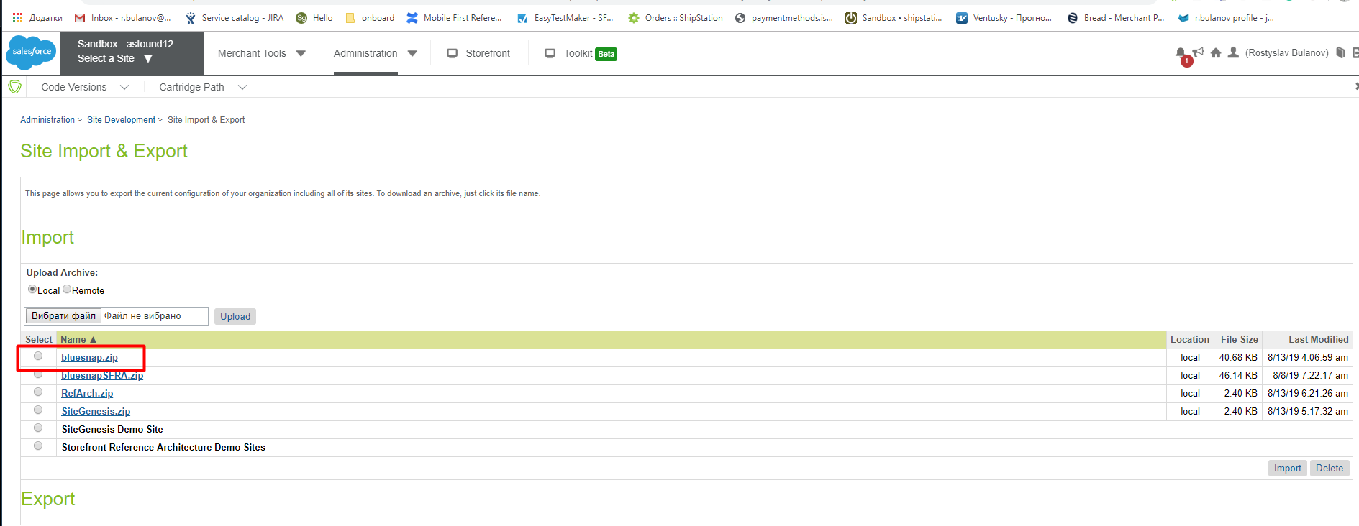

4. Configure Service credentials: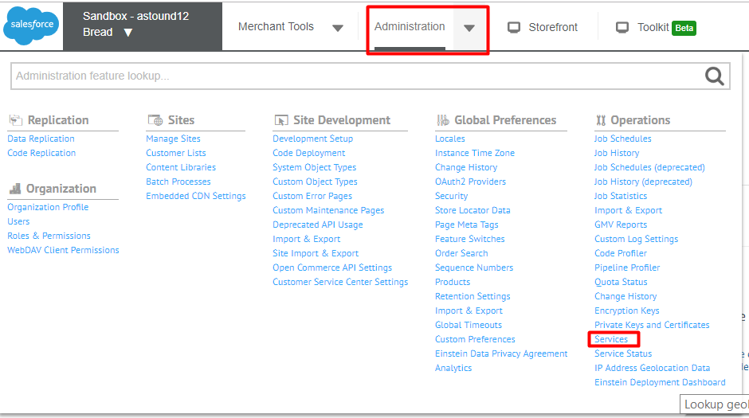

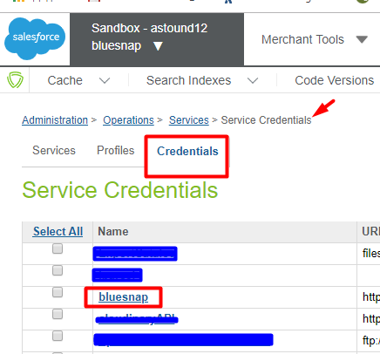

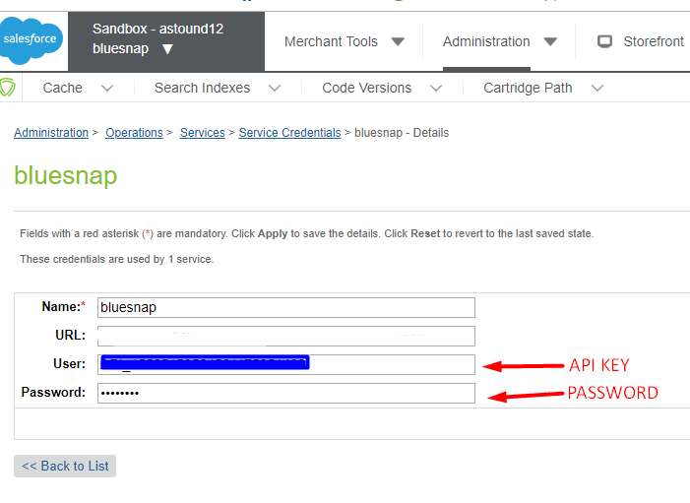

5. Add **bm_bluesnap** cartridge to the BM cartridge path.

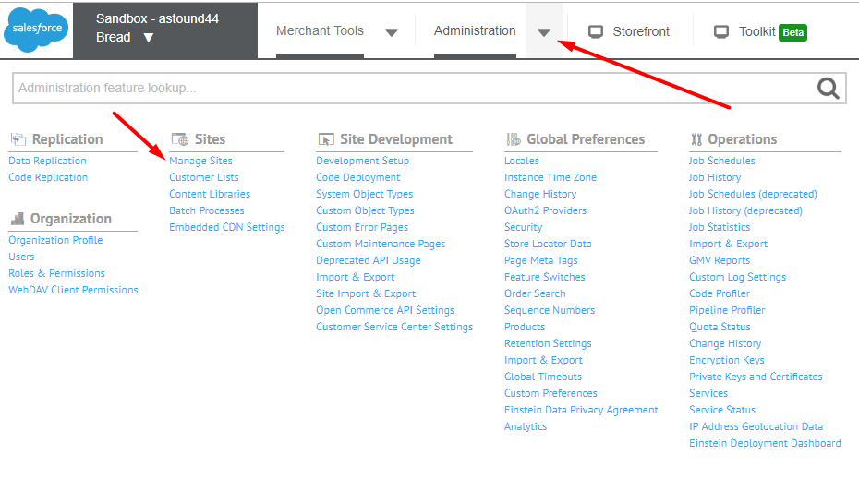

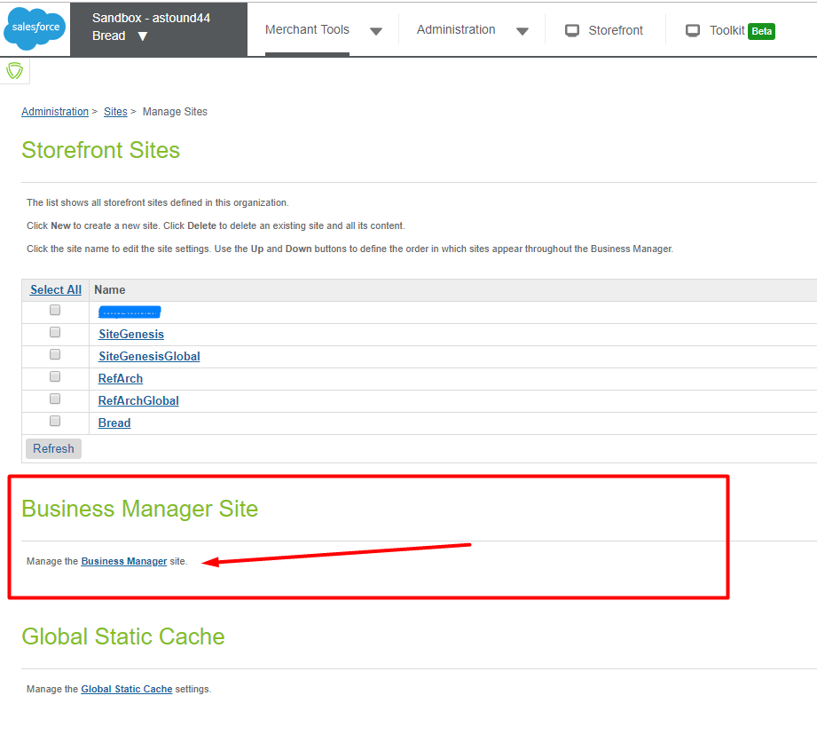

## 

6. Add permission for merchant to use BlueSnap BM extension. Go to

Administration > Organization > Roles > {Merchant Role} - Business Manager Modules

and select proper context

## 

7. Select the checkboxes and use the Update button at the bottom of the page to grant permissions to BlueSnap Settings and BlueSnap Reports Business Manager modules

## 

8. Reload page. BlueSnap section should appear in Merchant Tools

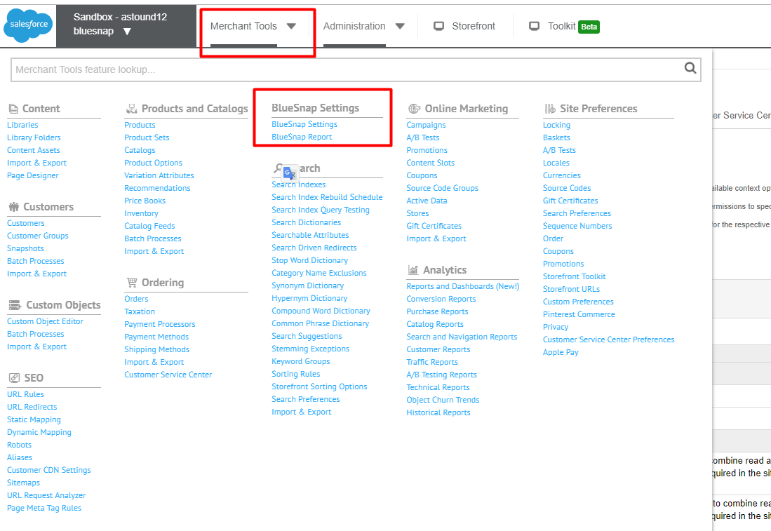

## 

## 

## **3.3 Configuring preferences:**

### **3.3.1 Example of configuring the cartridge via BM extension:**

Go to Business Manager: **Sites -> Your Site ->Merchant tools -> BlueSnap Settings**

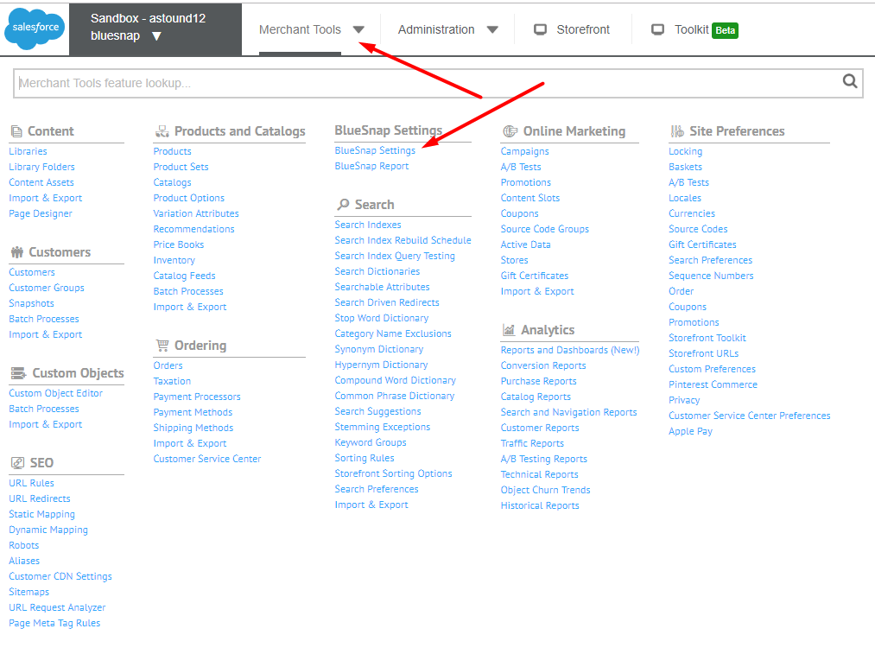

Below is an example of how to complete the fields in the blueSnap settings area: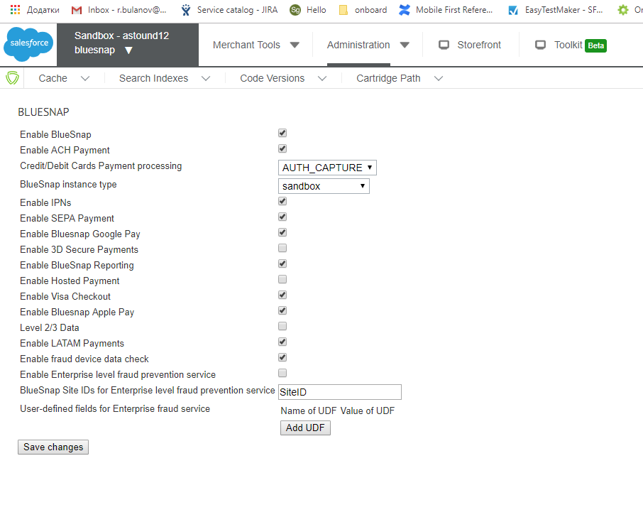

**Descriptions:**

* Enable BlueSnap — enables cartridge
* Enable ACH Payment
* Credit/Debit Cards Payment processing — AUTH_CAPTURE/ AUTH_ONLY
* BlueSnap instance type SANDBOX/PRODUCTION
* Enable IPNs — enables handling of Instant Payment Notifications
* Enable SEPA Payment
* Enable Bluesnap Google Pay
* Enable 3D Secure Payments
* Enable BlueSnap Reporting
* Enable Hosted Payment
* Enable Visa Checkout
* Enable Bluesnap Apple Pay
* Level 2/3 Data — Turns on level 3 data in the request
* Enable LATAM Payments
* Enable fraud device data check
* Enable Enterprise level fraud prevention service
* BlueSnap Site IDs for Enterprise level fraud prevention service
* User-defined fields for Enterprise fraud service

### **3.3.2 How to modify payment method name**

1. Go to Merchant Tools > Ordering > Payment Methods
2. Find payment method with **NEEDED** id.
3. Click on it in the **Name** column.
4. Change the name and press **Apply** button.

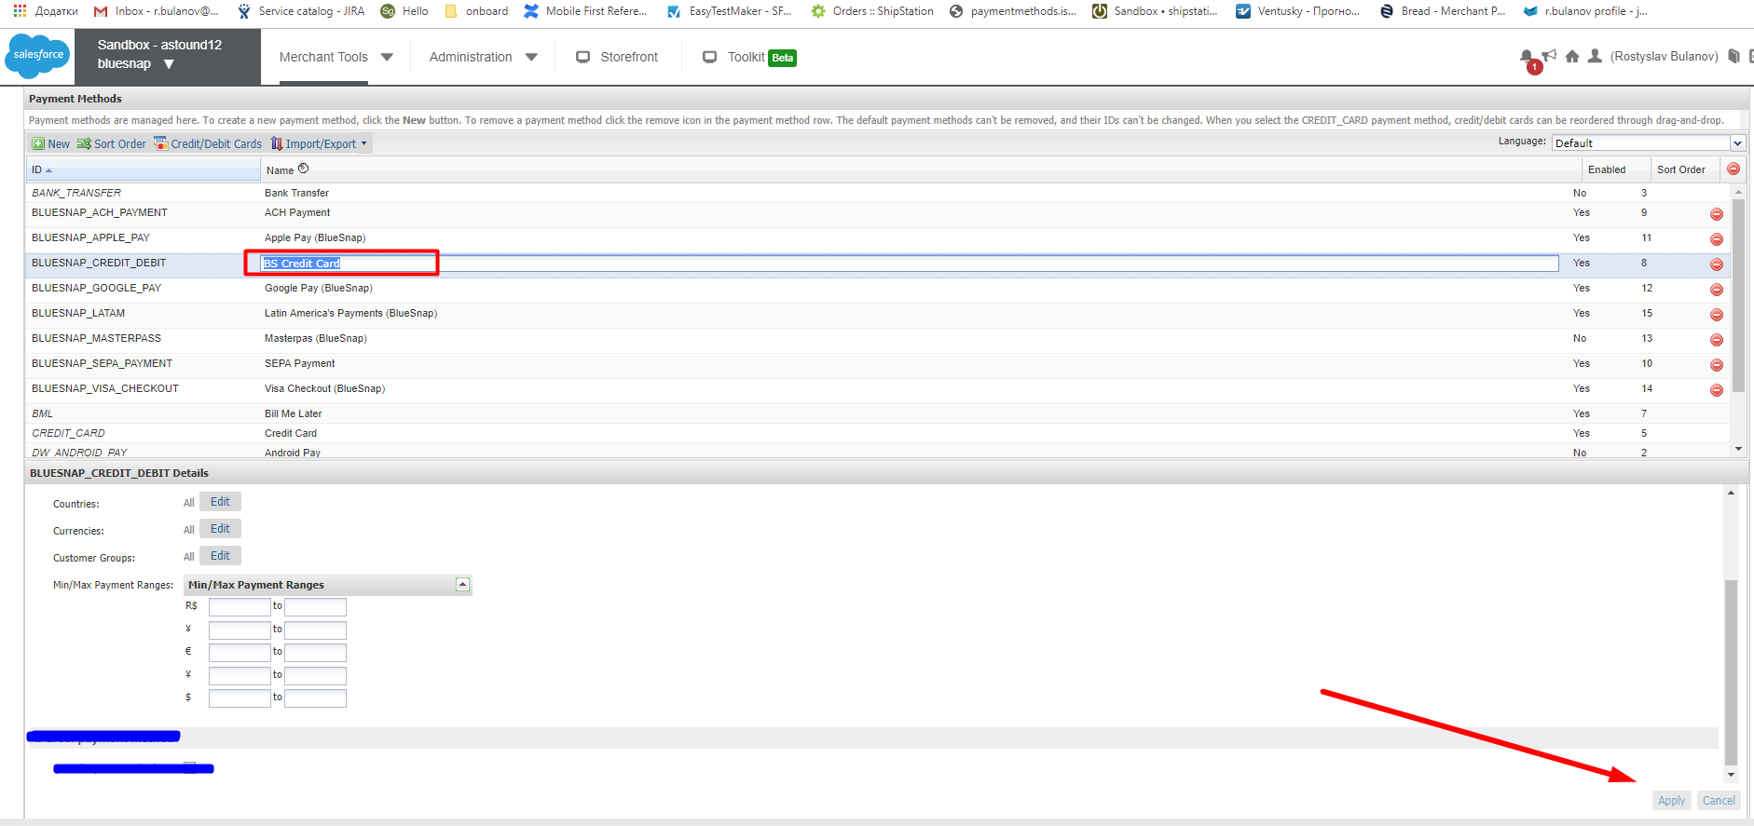

### **3.3.3 How to set SoftDescriptor for customer**

1. Go to Merchant Tools -> Customers

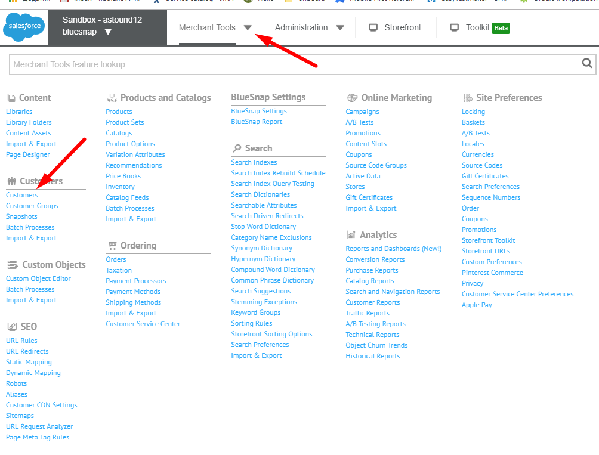

2. Select user

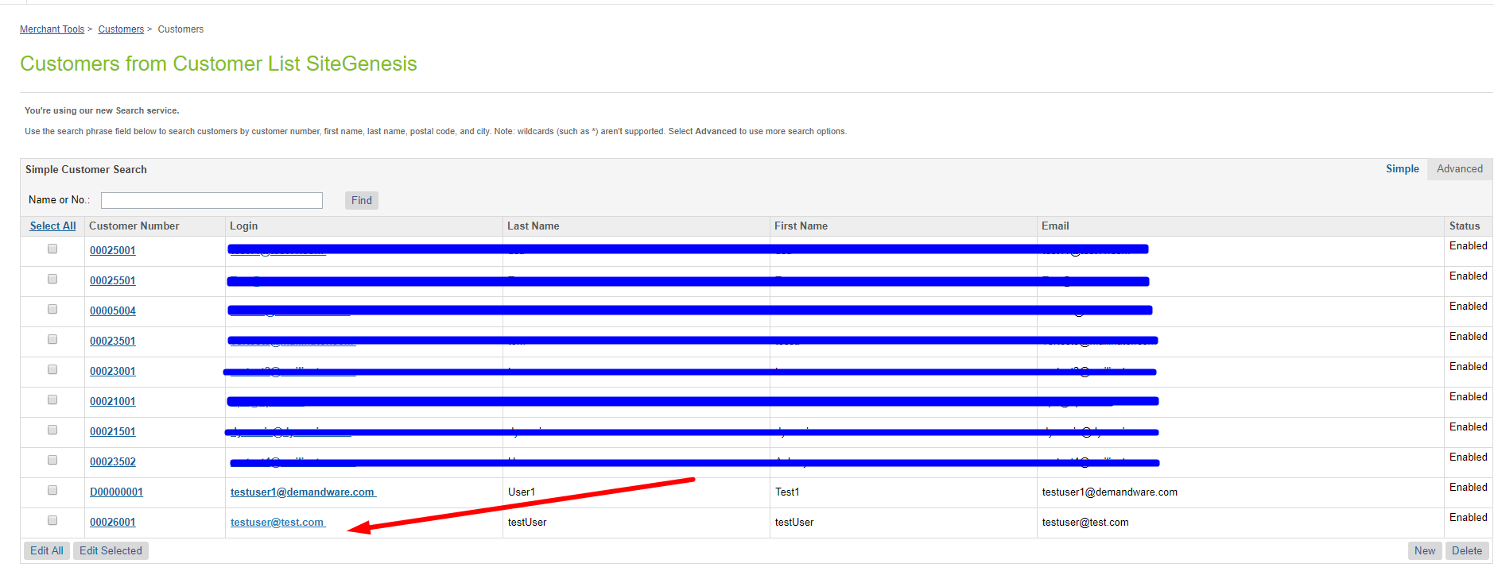

3. Find BlueSnap section fill the SoftDescriptor field and press Apply

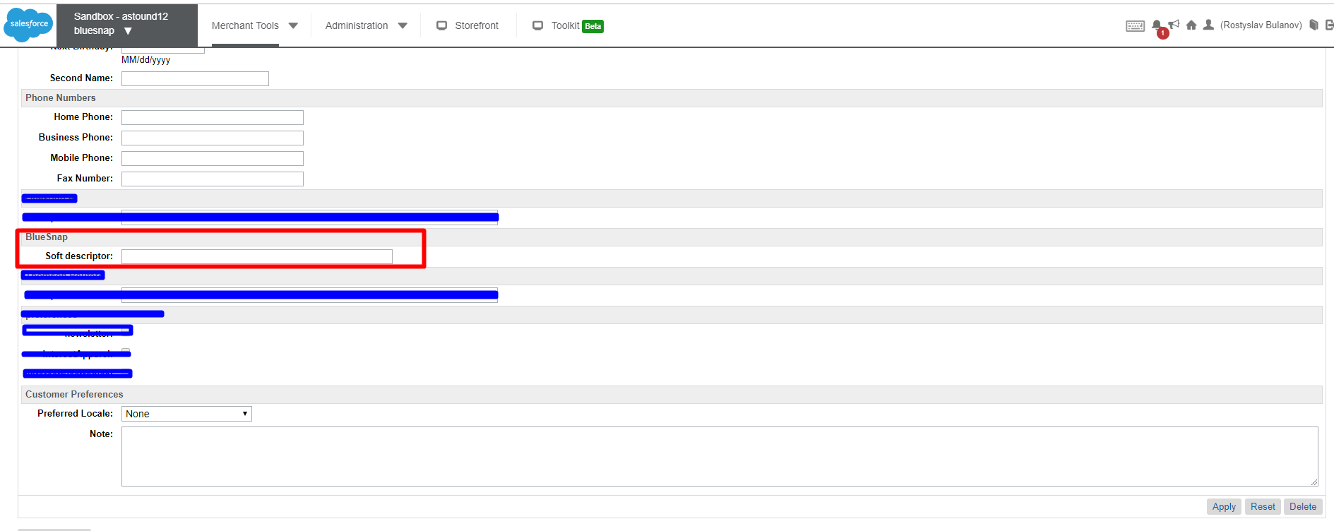

### **3.3.4 How to use Bluesnap Reports**

1. Go to Merchant Tools -> Bluesnap Settings -> BlueSnap Report

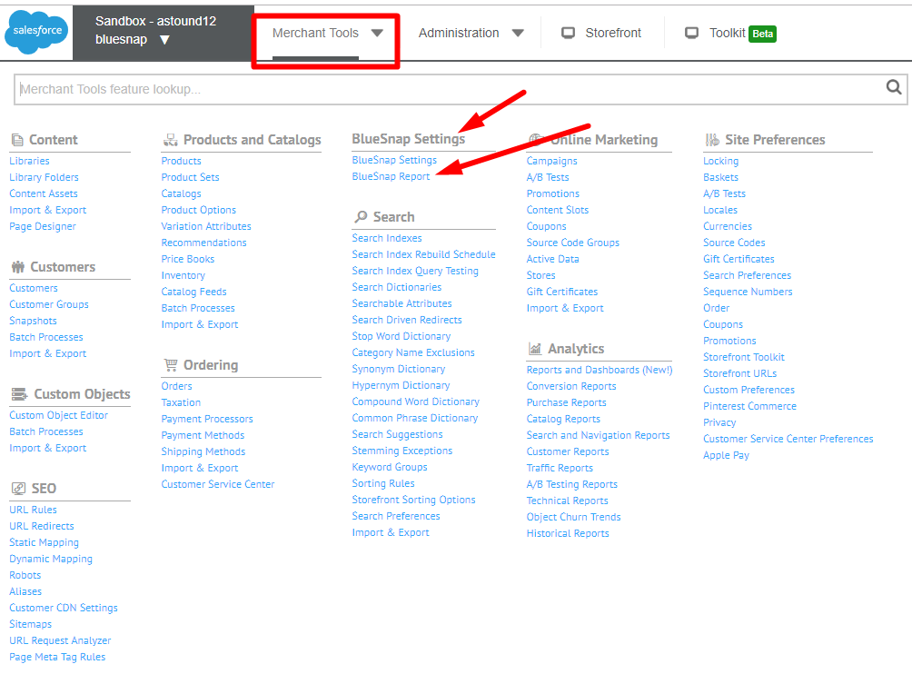

1. Choose Report type fill the form and press Submit

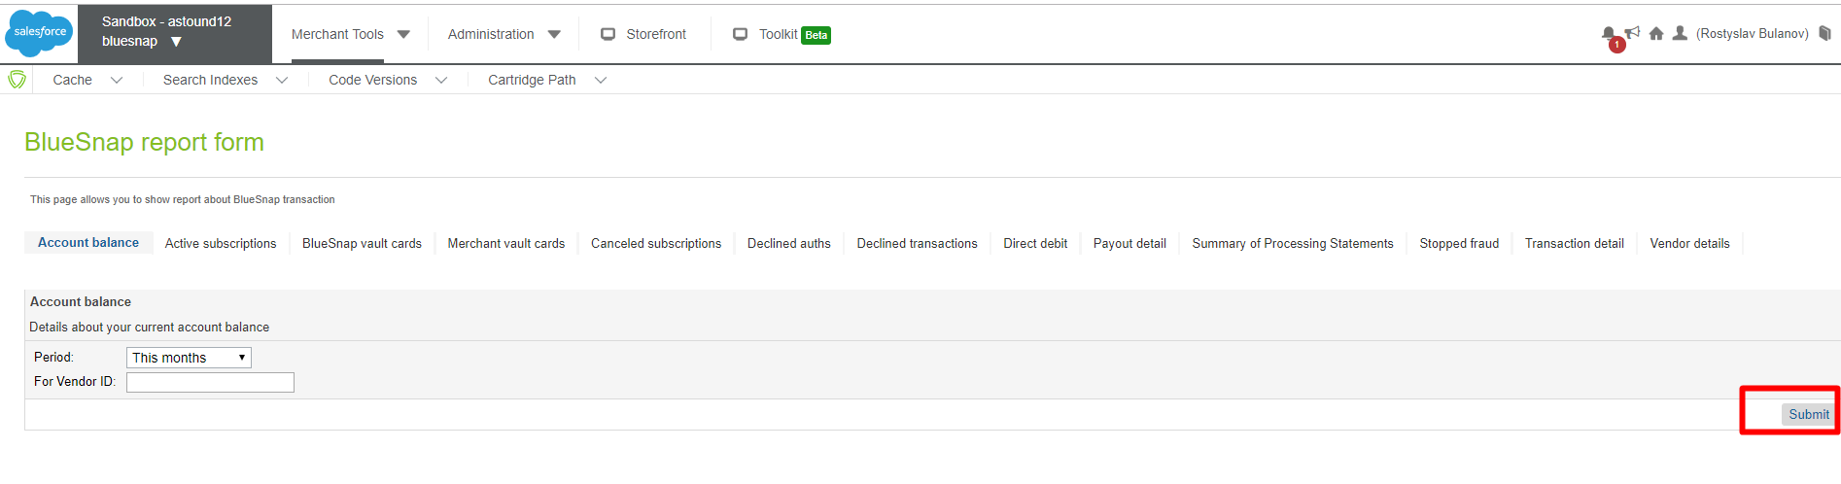

## **3.4 Integrating BlueSnap into your SiteGenesis storefront**

### **3.4.1 Perform changes in templates**

1. YOUR_CARTRIDGE_core/cartridge/templates/default/checkout/billing**/paymentmethods.isml**

Put the following

|  |
| --- |
| <isset name="getBlueSnapPreference" value="${require('int_bluesnap/cartridge/scripts/lib/bluesnapdata.js')}" scope="page"/> |

raw in line 13 and Insert the below code block inside of the *<isloop items="${pdict.CurrentForms.billing.paymentMethods.selectedPaymentMethodID.options}" var="paymentMethodType">* tag:

|  |
| --- |
| <isif condition="${paymentMethodType.value.indexOf('BLUESNAP_') > -1 && !getBlueSnapPreference('Enable')}"><iscontinue/></isif>  <isif condition="${paymentMethodType.value.equals('BLUESNAP_ACH_PAYMENT') && !getBlueSnapPreference('ACH')}"><iscontinue/></isif>  <isif condition="${paymentMethodType.value.equals('BLUESNAP_SEPA_PAYMENT') && !getBlueSnapPreference('SEPA')}"><iscontinue/></isif>  <isif condition="${paymentMethodType.value.equals('BLUESNAP_APPLE_PAY') && !getBlueSnapPreference('ApplePay')}"><iscontinue/></isif>  <isif condition="${paymentMethodType.value.equals('BLUESNAP_GOOGLE_PAY') && !getBlueSnapPreference('GooglePay')}"><iscontinue/></isif>  <isif condition="${paymentMethodType.value.equals('BLUESNAP_MASTERPASS') && !getBlueSnapPreference('Masterpass')}"><iscontinue/></isif>  <isif condition="${paymentMethodType.value.equals('BLUESNAP_VISA_CHECKOUT') && !getBlueSnapPreference('VisaCheckout')}"><iscontinue/></isif>  <isif condition="${paymentMethodType.value.equals('BLUESNAP_LATAM') && !getBlueSnapPreference('LATAM')}"><iscontinue/></isif> |

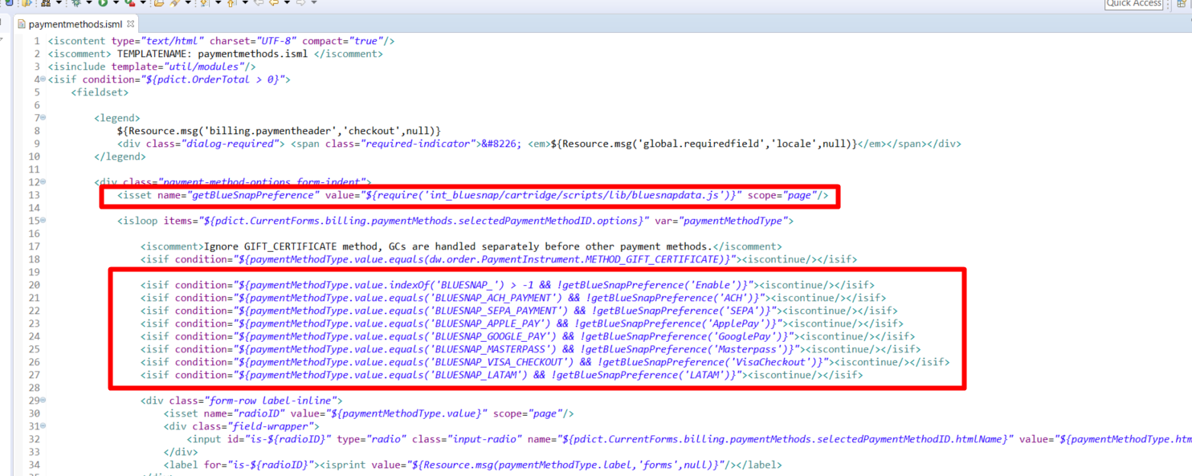

Paste the following line into the 148 line

|  |
| --- |
| <isinclude template="bspaymentmethods.isml"> |

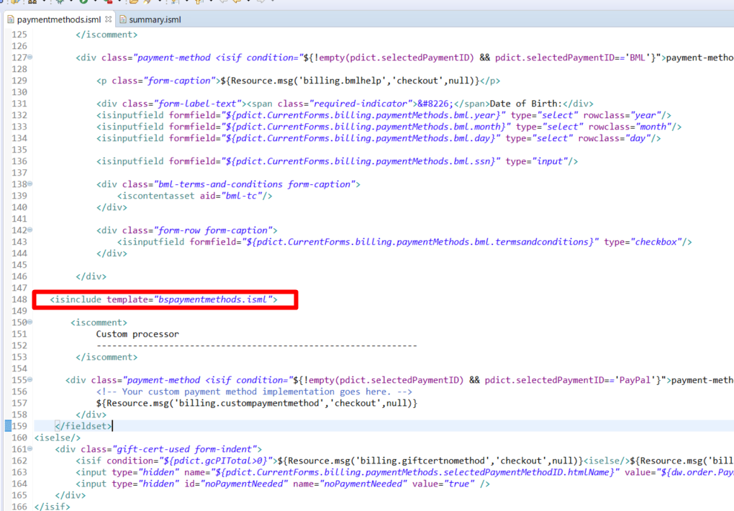

1. YOUR_CARTRIDGE_core/cartridge/templates/default/checkout/summary/**summary.isml** Paste following code sample into the end of template before closing </isdecorate> tag:

|  |
| --- |
| <isinclude template="bluesnap/applepay"/>  <isinclude template="bluesnap/googlepay"/>  <isinclude template="bluesnap/visacheckout"/> |

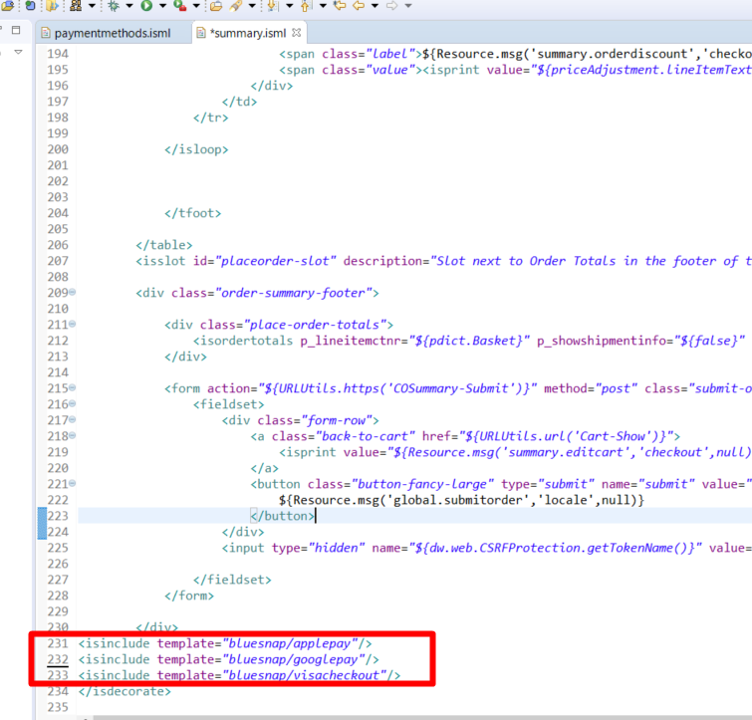

1. YOUR_CARTRIDGE_core/cartridge/templates/default/util/**modules.isml** Paste following code sample into the end of template:

|  |
| --- |
| <iscomment>  Render Bluesnap vaulted payments dropdown selector  paymentsources: array of unified payment sources data  </iscomment>  <ismodule template="vaultpaymentselector"  name="vaultpaymentselector"  attribute="select_id"  attribute="paymentsources"  attribute="parentselector"  /> |

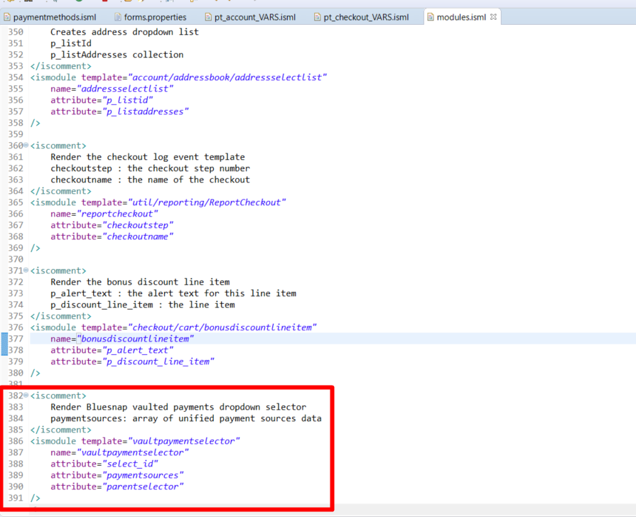

1. YOUR_CARTRIDGE_core/cartridge/templates/default/account/**pt_account_VARS.isml**

insert following line into the template:

|  |
| --- |
| <!-- Bluesnap Vault UI Scripts -->  <link rel="stylesheet" type="text/css" href="${dw.web.URLUtils.staticURL("/css/bluesnapcustom.css")}">  <script src="${dw.web.URLUtils.staticURL('/js/bluesnap-account.js')}"></script> |

1. YOUR_CARTRIDGE_core/cartridge/templates/default/account/**pt_checkout_VARS.isml**

insert following line into the template:

|  |
| --- |
| <link rel="stylesheet" type="text/css" href="${dw.web.URLUtils.staticURL("/css/bluesnapcustom.css")}">  <script src="${dw.web.URLUtils.staticURL('/js/bluesnap-checkout.js')}"></script> |

**Note:** In case you need to build client’s javascript in your own way: all client javascript files are located in static folders of **int_bluesnap** and **int_bluesnap_controllers** cartridges.

# **Operations, Maintenance**

## **Data Storage**

*Intentionally left blank.*

## **Availability**

When service is down any attempt to pay with BlueSnap payment instrument will result in error. In order to secure safe and consistent storefront payment flow BlueSnap payment instrument can be disabled until service functioning is restored.

## **Support**

*Intentionally left blank.*

# **User Guide**

## **Roles, Responsibilities**

*Intentionally left blank.*

## **Business Manager**

*Configuration options described above in 3.1.*

## **Storefront Functionality**

The BlueSnap cartridge adds payment methods to the storefront, and gives opportunity to place order via these payment methods. All these payment methods are working through the BlueSnap — All-in-One Payment Platform. Also it allows customer to store credit cards on BlueSnap side and pay with one click

# **Known Issues**

*Intentionally left blank.*

# **Release History**

|  |  |  |
| --- | --- | --- |
| **Version** | **Date** | **Changes** |
| 19.1.0 | August 2019 |  |
| 21.1.0 | October 2021 | Updated to latest SFRA version (6.0.0) |